**Adding Proxy to our 2-tier project**

* We have already deployed our 2 tier project in the container.
* Now we have to add the proxy.
* We need to create a Dockerfile for the proxy.
* Go to the instance and create a directory named proxy.
* Enter the directory using cd command and create a Dockerfile inside proxy.
* Add the instructions as given below.

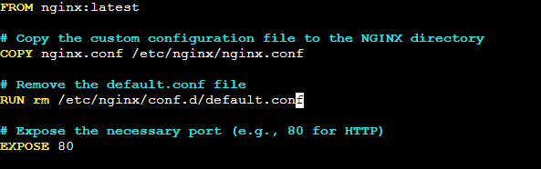

* In the Dockerfile we are copying the nginx.conf from our local instance to the container.
* So we need nginx.conf file on our instance.
* Create a nginx.conf file.
* Add the configuration to the file.

**user nginx;**

**worker_processes 1;**

**error_log /var/log/nginx/error.log warn;**

**pid /var/run/nginx.pid;**

**events {**

**worker_connections 1024;**

**}**

**http {**

**include /etc/nginx/mime.types;**

**default_type application/octet-stream;**

**log_format main '$remote_addr - $remote_user [$time_local] "$request" '**

**'$status $body_bytes_sent "$http_referer" '**

**'"$http_user_agent" "$http_x_forwarded_for"';**

**access_log /var/log/nginx/access.log main;**

**sendfile on;**

**tcp_nopush on;**

**tcp_nodelay on;**

**keepalive_timeout 65;**

**types_hash_max_size 2048;**

**include /etc/nginx/conf.d/*.conf;**

**server {**

**listen 80;**

**server_name localhost;**

**location / {**

**proxy_pass http://** **52.91.38.89:8080/student/;**

**}**

**}**

**}**

* The configuration file contains default configuration.
* We have only added the proxy_pass.

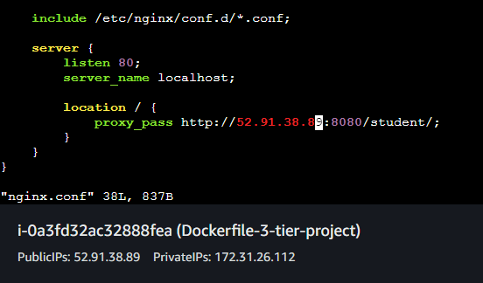

* In our Dockerfile we are also removing the default.conf file from the container which shows the default page welcome page of nginx.
* Now change the directory to /home/ec2-user.
* Open the script.
* Add the commands to build the nginx image from the Dockerfile.
* Also add the commands to run the image to create a container from the image.

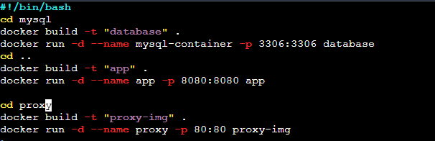

* Now run the script.
* Try to hit the IP of instance.
* Hit the IP of the instance with the port number 80.
* Our page is visible.

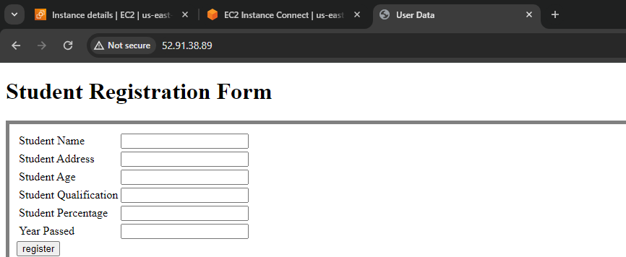

* Fill the registration form and click register.

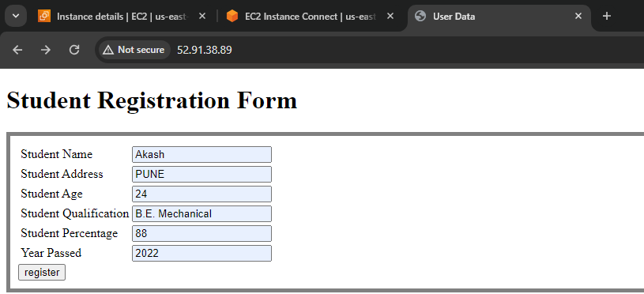

* Our data is also saved in the database.

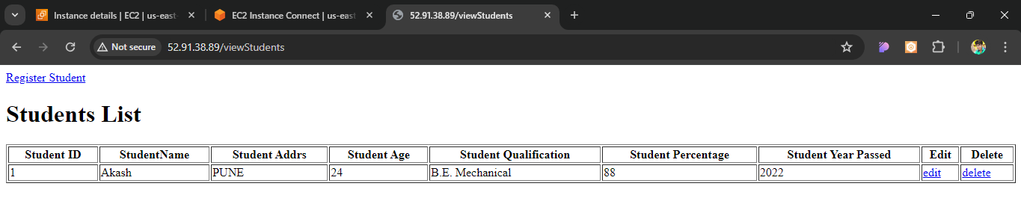

* Proxy is working.